**FINAL Lab Project: Single Cycle CPU-LITE**

**MdShahid Bin Emdad**

**May 22, 2022**

**CSC 34200/34300**

Table of Contents

Objective: 2

Description of Specifications, and Functionality: 2

Components: 2

R-type Instructions: 3

I-type Instructions: 3

Design Implementation: 4

Single Cycle CPU lab: 5

Multiplexer: 7

Register File: 8

Sign Extender: 9

Program Counter: 10

Data Memory: 11

Instruction Register: 12

Instruction Memory: 13

Arithmetic Logic Unit (ALU): 14

Control Unit: 15

MIPS: 16

Block Diagrams: 19

MIPS: 21

Simulation: 22

Conclusion: 24

# Objective:

The objective of this assignment is to learn and develop a single cycle CPU. We were instructed to design and implement in VHDL CPU controller that generates control signals to determine the data path for each instruction. We needed to write a program to compute the sum of integers using instructions and single cycle CPU. Overall, this lab is to design single cycle CPU based on the MIPS instruction set architecture

# Description of Specifications, and Functionality:

The digital system I used in this assignment is Quartus Prime 20.1.1 and ModelSimSetup-20.1.1. There two packages needed are cyclonev and cyclonevi (both versions are 20.1.1). In the VHDL editor, I wrote my VHDL code to get the circuit output and then used Modelsim to simulate and run my circuit over time (ns unit).

We needed to implement MIPS instructions listed below:



## Components:

Half Adder Ports: I used two inputs one for the first operand of the adder and other one is the second operand of the adder. I also used carry which is the bit that is carried in from the next less significant stage.

Full Adder Ports: I used two inputs one for the first operand of the adder and other one is the second operand of the adder. I also used cin which is the bit that is carried in from the next less significant stage. I used cout for the output which is bit that is carried over from an addition when necessary and sum is the last bit of the result.

Instruction Memory: I used 2 cins, (cin1 and cin2) which are the first and second operand of the adder for the 16 bits. I also had op which is the bit that carried in from the less significant stage. For the outputs, I had neg which is the carry output that carried in from addition, sum (sum of the two inputs, cin1 and cin2), overflow which checks for overflow errors and finally zero for two input addition.

Data Memory: I used two operands. The first operand of the adder and other one is the second operand of the adder. Then, I used obit which is the bit that carried from the less significant stage. I had carried for the bit output from addition, sum for the inputs addition, overflow which checks for overflow errors and finally zero for two input addition.

ALU: The inputs are 32-bit registers (RS, RT) to compute operations, 16-bit immediate to compute immediate operations, 32-bit MDR, clock and operation. The outputs are 32-bit register RD and 3 flags: zero, negative, overflow. I also used the other codes as a component to get the waveform.

Extender: I am using this to extend the most significant bit for IMM. It is used to extend the 16bit register data to 32bit register so I can use the 32-bit add/sub.

## R-type Instructions:

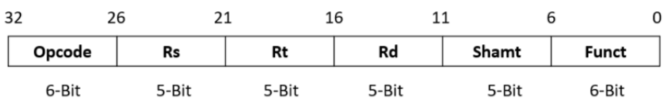

The R-type instruction is divided into 6 parts according to the above structure. First, the opcode is 0b000000. For all R-type commands. Second, the Rs, Rt, and Rt fields are all two source and destination indexes. Each register in addition, the Shamt field specifies the number of bits to shift the contents of a. Registers-Applies only to shift instructions sll, srl, and sra.

|  |  |  |  |  |  |
| --- | --- | --- | --- | --- | --- |
| R-type Instructions | | | | | |
|  | Add | Sub | OR | Mult | Div |
| RegDst | 1 | 1 | 1 | 1 | 1 |
| AluSRC | 0 | 0 | 0 | 0 | 0 |
| MemToReg | 0 | 0 | 0 | 0 | 0 |
| RegWrite | 1 | 1 | 1 | 1 | 1 |
| MemWrite | 0 | 0 | 0 | 0 | 0 |
| PCSrc | 0 | 0 | 0 | 0 | 0 |
| ExtOp | X | X | 0 | X | X |
| ALUOp | 0000 | 0001 | 0010 | 0100 | 0101 |

## I-type Instructions:

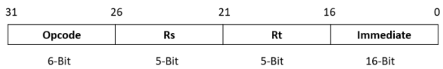

Unlike the RType statement, the IType statement is split into four fields according to the structure above. First, the opcode distinguishes between IType statements. Next, Rs and Rt are the source indexes / addresses of the two source registers. Finally, the last 16 bits or immediately after are zero-extended or sign-extended to a 32-bit value, depending on the operation.

|  |  |  |  |  |  |
| --- | --- | --- | --- | --- | --- |
| I-type Instructions | | | | | |
|  | AddI | ORI | LW | SW | Beq |
| RegDst | 0 | 0 | 0 | X | X |
| AluSRC | 1 | 1 | 1 | 1 | 1 |
| MemToReg | 0 | 0 | 1 | X | X |
| RegWrite | 1 | 1 | 1 | 0 | 0 |
| MemWrite | 0 | 0 | 0 | 1 | 0 |
| PCSrc | 0 | 0 | 0 | 0 | 1 |
| ExtOp | 1 | 0 | 1 | 1 | X |
| ALUOp | 0000 | 0010 | 0000 | 0000 | 0000 |

## Design Implementation:

Now we have the breakdowns of the instructions and components, we need go for design implementation. The instructions follow different types of formats, not all instructions will handle the same way. Therefore, we need some mechanism to organize and control the data paths for each instruction We can see in the figure 1 the CPU controller operation.

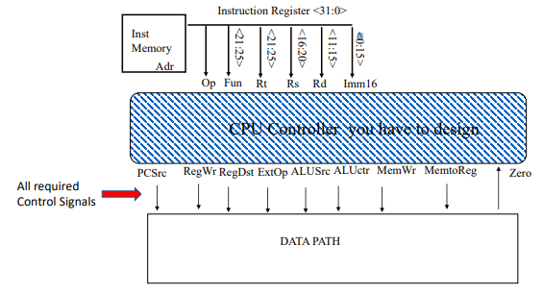

Figure 1: Visualization of CPU Controller Operation

## Single Cycle CPU lab:

|  |  |  |
| --- | --- | --- |
| Signal | Value = 0 | Value = 1 |
| Branch | PC < = PC +4 | PC < = PC +4 + {SignExt(Imm), <<2} |
| ALUsrc | Operand 2 <= BusB | Operand 2 <= SignExt(Imm) |
| ExtOp | Zero Extend | Sign Extend |
| RegWrite | No write | The register on the BusW input is written with the value on the Write data input |
| RegDst | ALUResult < RT | ALUResult < RD |
| MemWrite | No write | Write to memory |
| MemRd | No read | Read from memory |
| MemtoReg | The value fed to the register BusW input comes from the ALU | The value fed to the register BusW input comes from the Data Memory |
| Jump | No jump | Jump to target address |
| ALUCtrl | 4-Bit vector that serves as an input to the Arithmetic Logic Unit (ALU) to perform the necessary arithmetic operation. | 4-Bit vector that serves as an input to the Arithmetic Logic Unit (ALU) to perform the necessary arithmetic operation. |

In figure 2, we can see the “A Single Cycle CPU” block diagram. This is the last step and the intended design to create. We will be using Quartus to build it from the VHDL code.

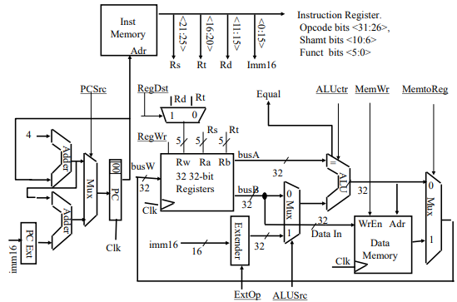

Figure 2: A Single Cycle CPU

In figure 3, we can see the project directory for the CPU lab.

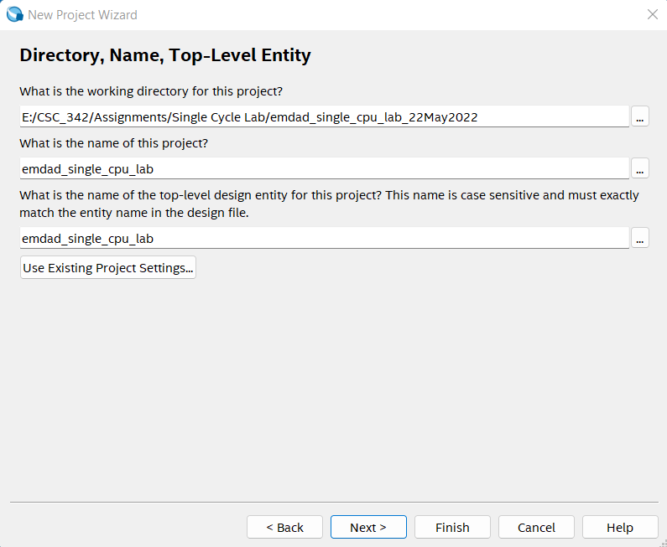

Figure 3: project directory for the CPU lab.

In figure 4, we can see the project summary for the CPU lab project.

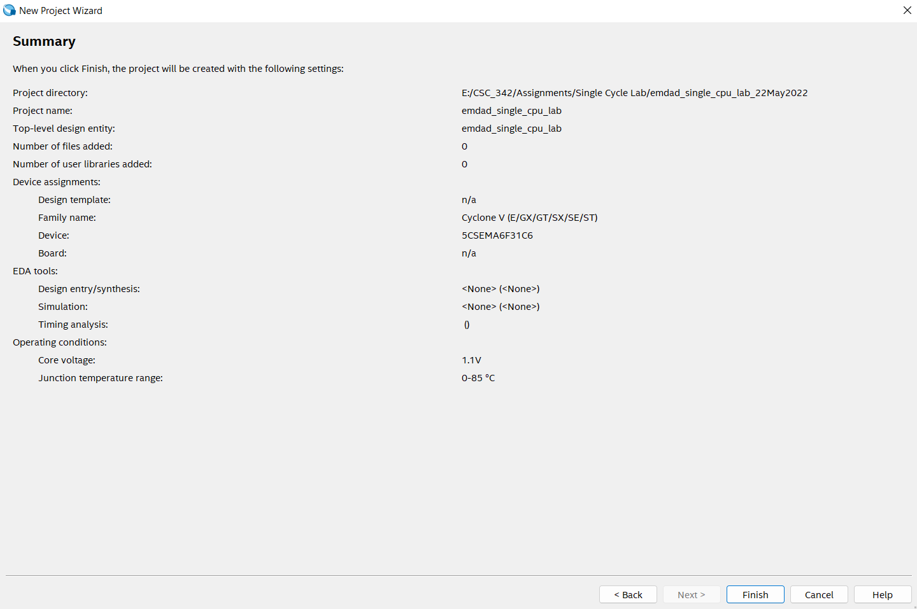

Figure 4: project summary for the CPU lab project.

## Multiplexer:

In figure 5, we can see the VHDL code for multiplexer. I have 3 inputs and 1 output for this code.

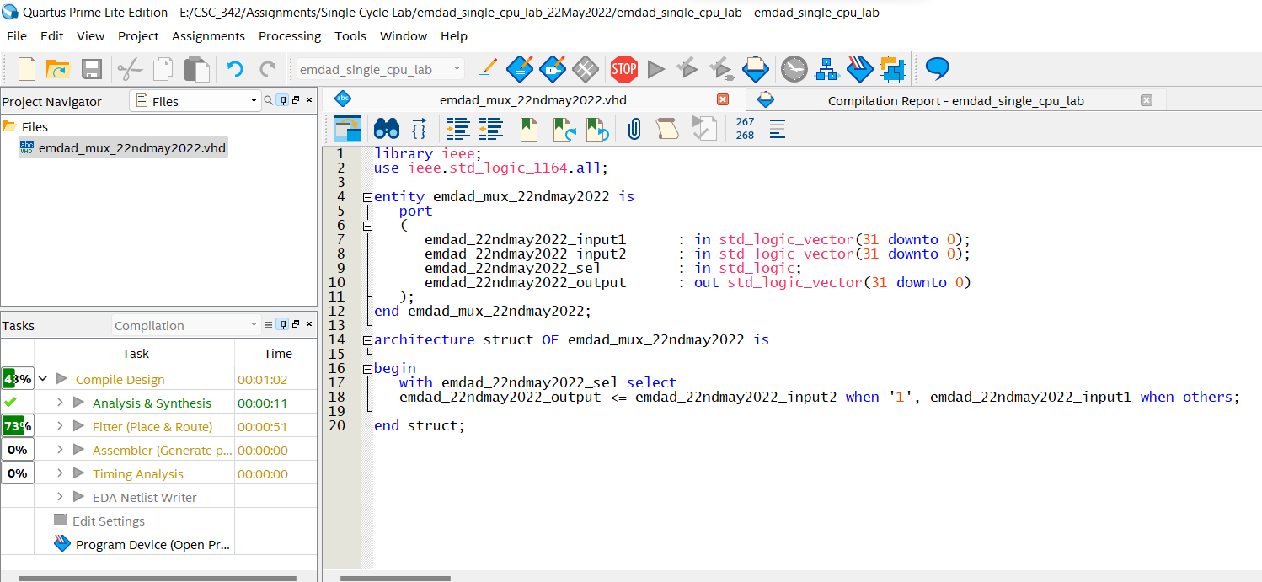

Figure 5: VHDL code for multiplexer

In figure 6, we can see that the code compiled successfully.

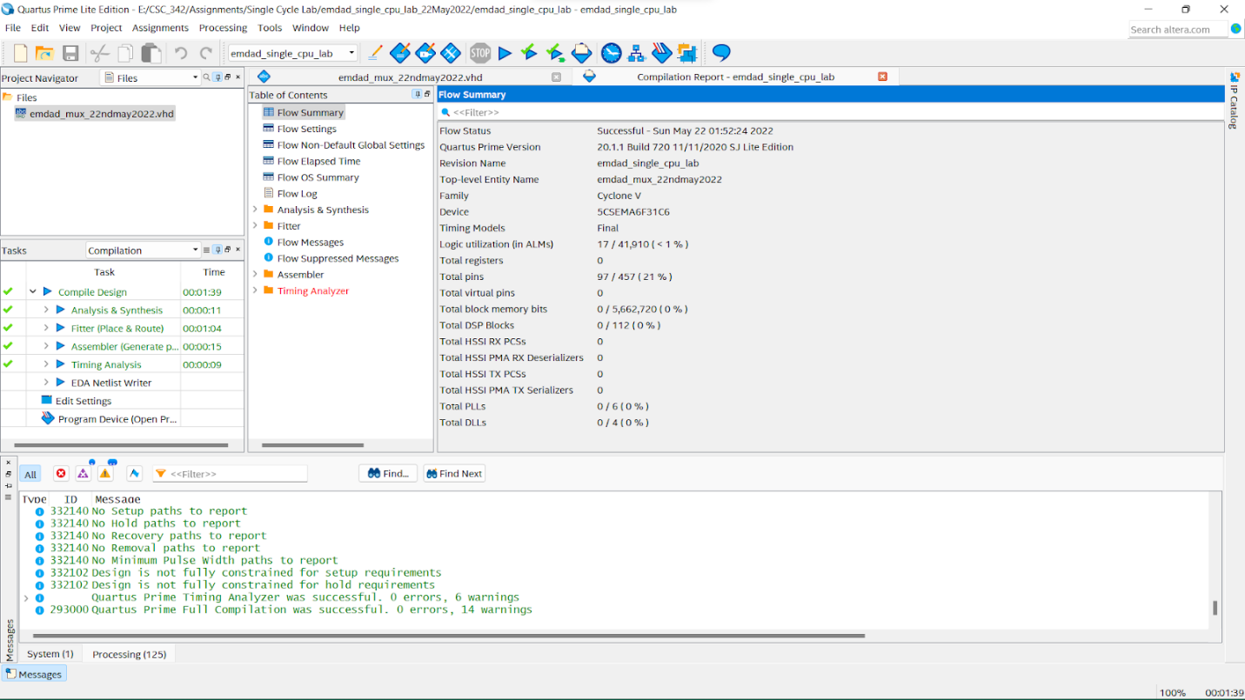

Figure 6: compiled successfully

## Register File:

In figure 7, we can see the VHDL code the register file. I have 6 inputs and 2 outputs for the registers read and output.

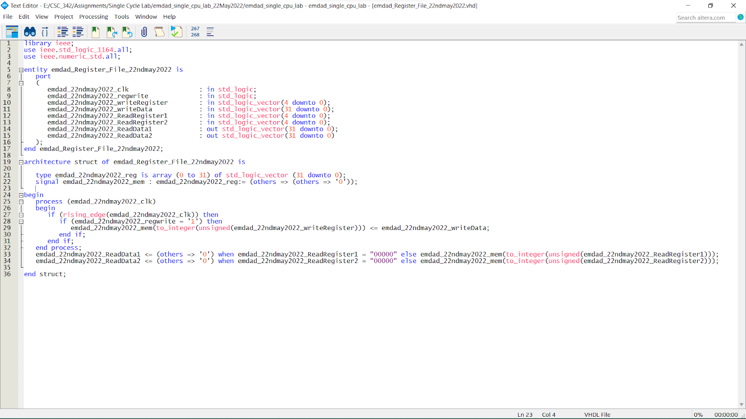

Figure 7: VHDL code the register file

In figure 8, we can see that the code compiled successfully.

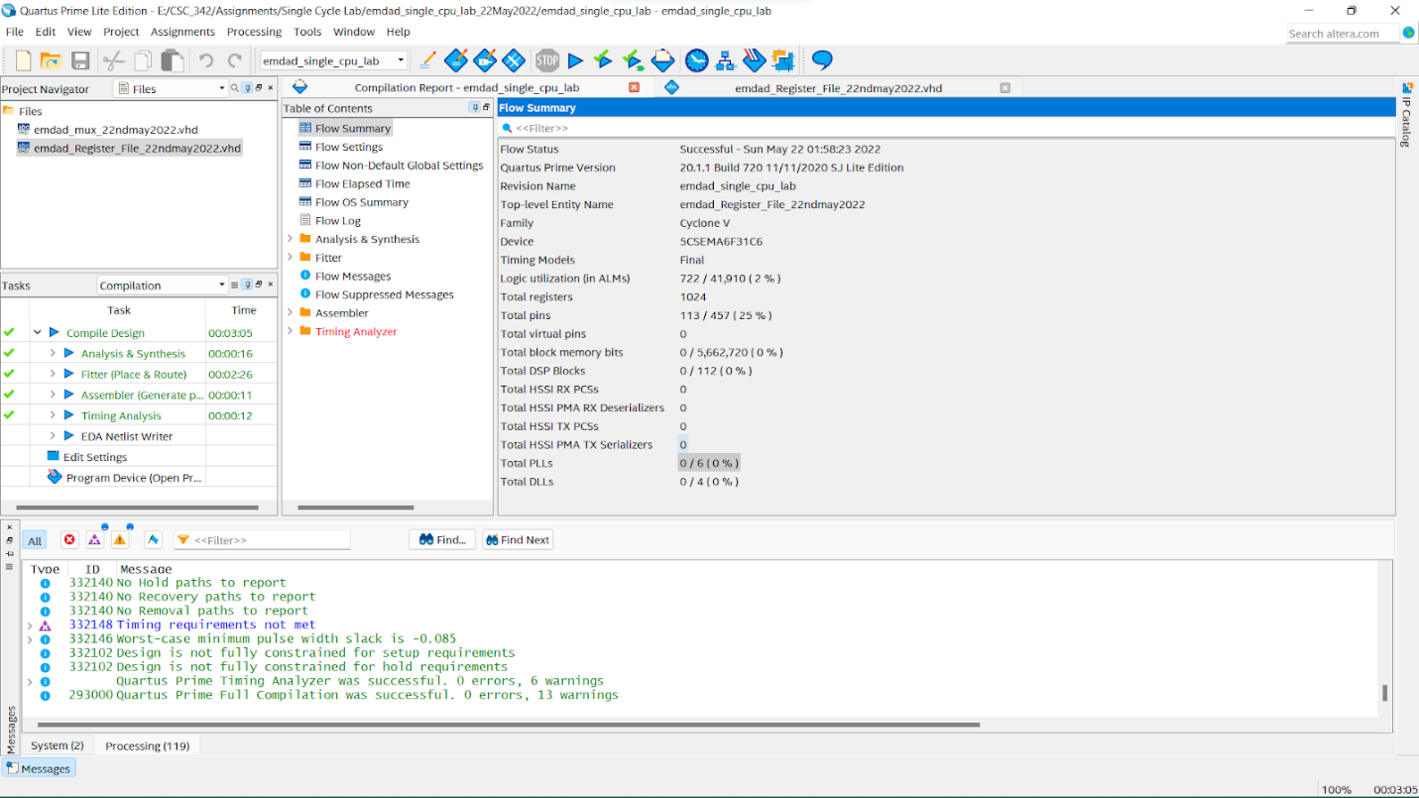

Figure 8: compiled successfully.

## Sign Extender:

In figure 9, we can see the VHDL code the sign extender. We will be using to extend the bit from 16bits to 32bits. I have 1 input and 1 output.

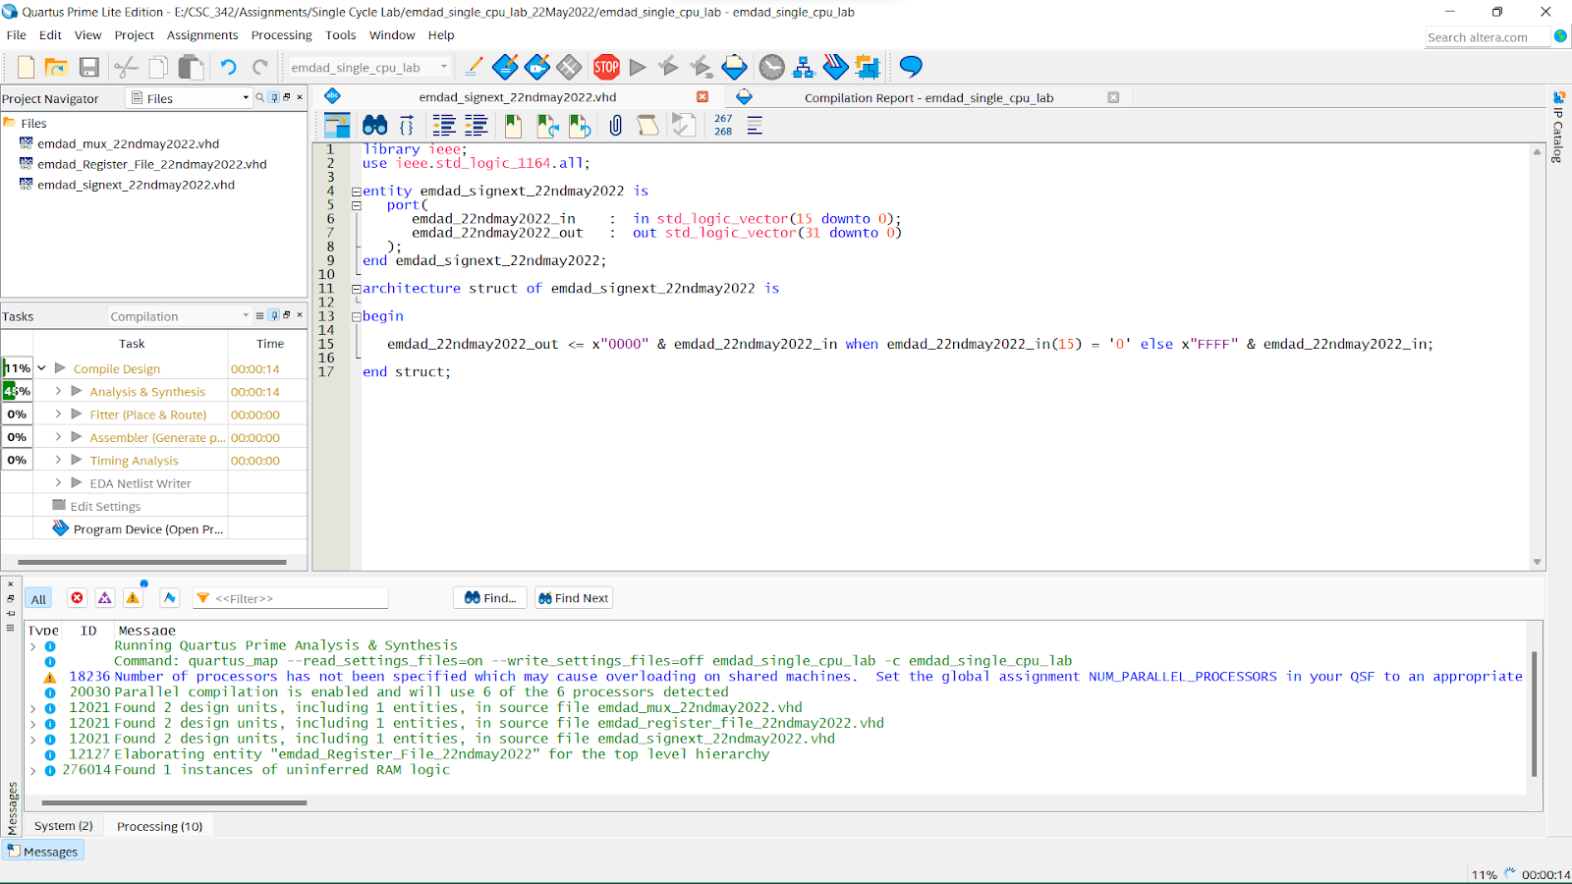

Figure 9: VHDL code the sign extender

In figure 10, we can see that the code compiled successfully.

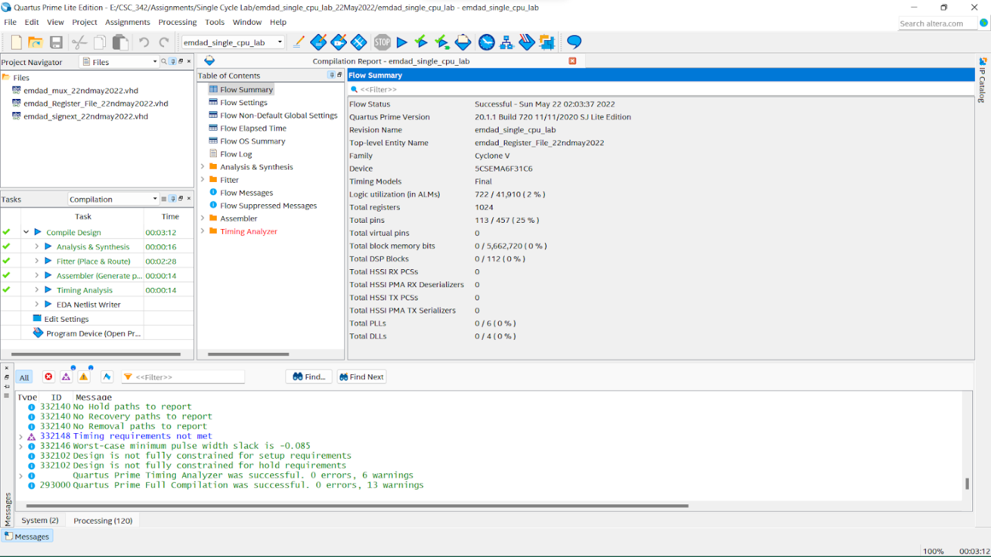

Figure 10: compiled successfully.

## Program Counter:

In figure 11, we can see the VHDL code the program counter. I have 3 inputs and 1 output.

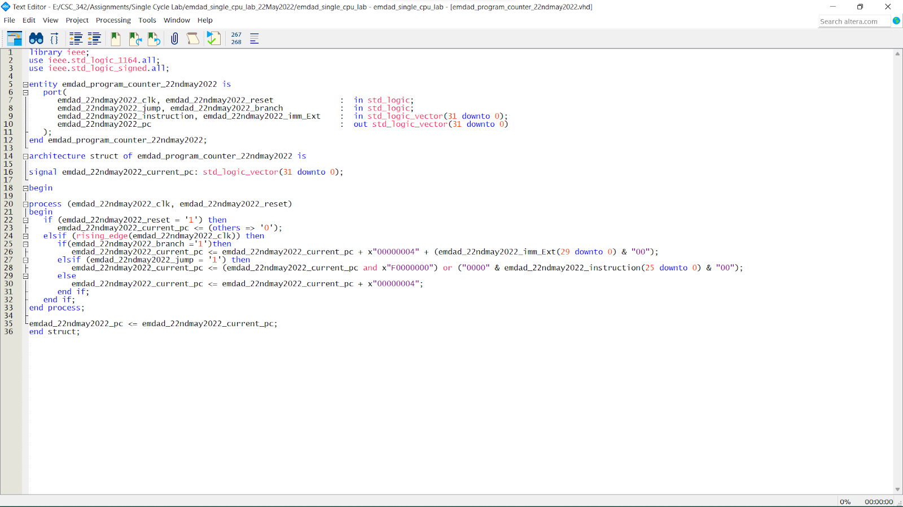

Figure 11: VHDL code the program counter

In figure 12, we can see that the code compiled successfully.

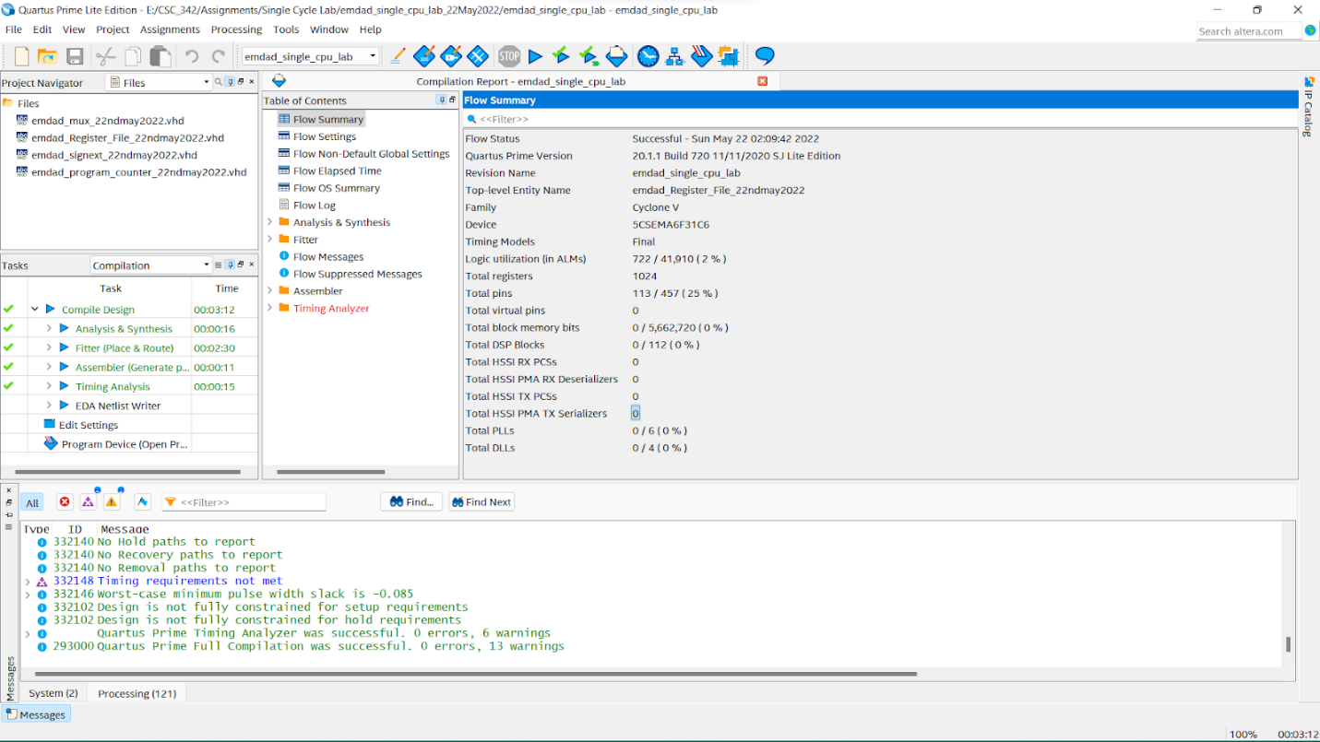

Figure 12: compiled successfully

## Data Memory:

In figure 13, we can see the VHDL code the data memory. We will be using to extend the bit from 16bits to 32bits. I have 4 inputs and 1 output.

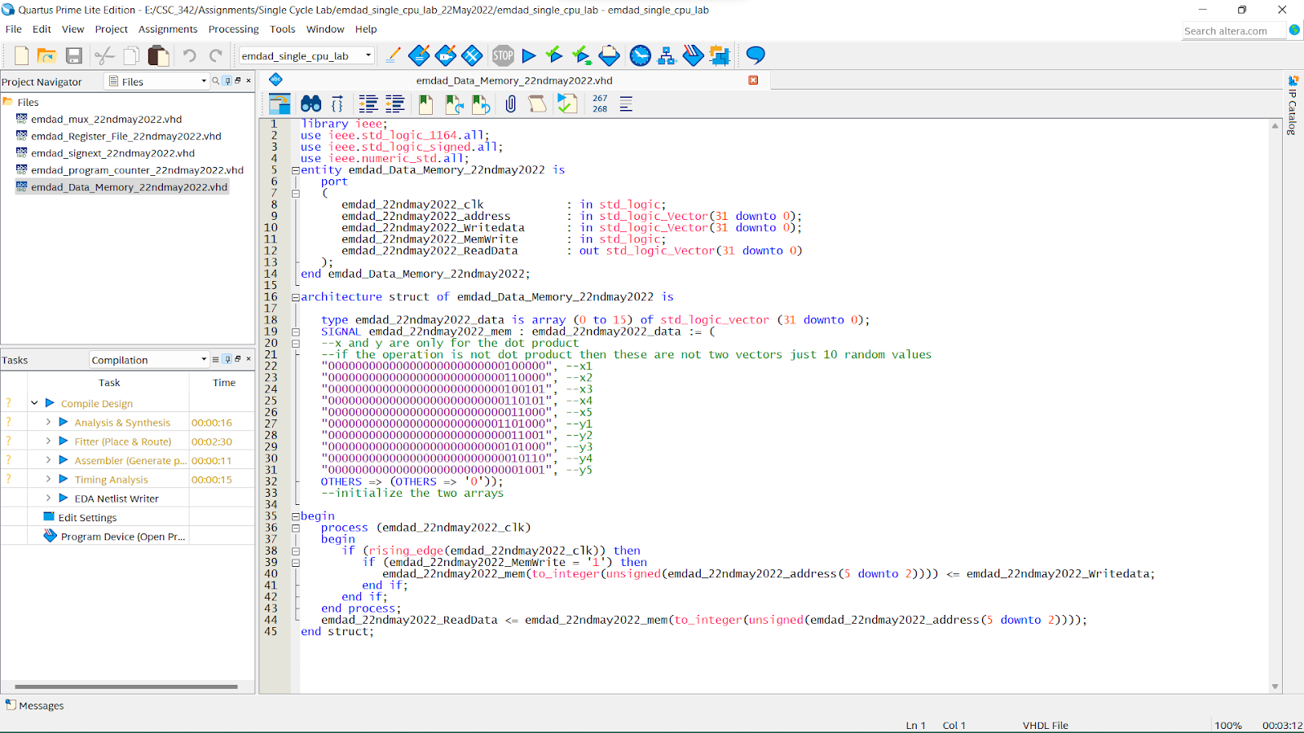

Figure 13: VHDL code the data memory

In figure 14, we can see that the code compiled successfully.

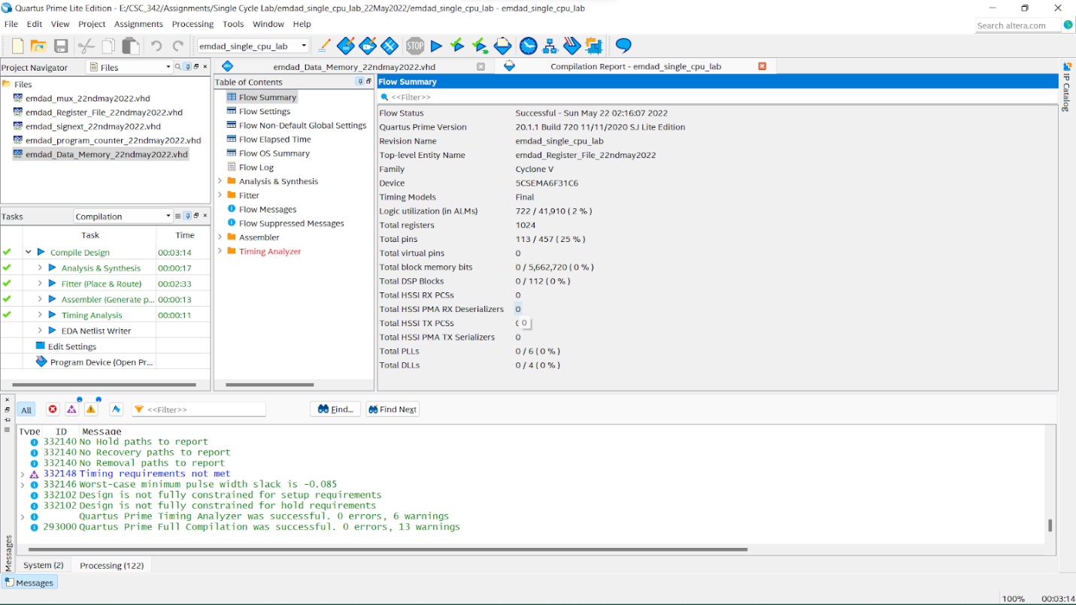

Figure 14: compiled successfully

## Instruction Register:

In figure 15, we can see the VHDL code the instruction Register. I have 1 input and 4 outputs.

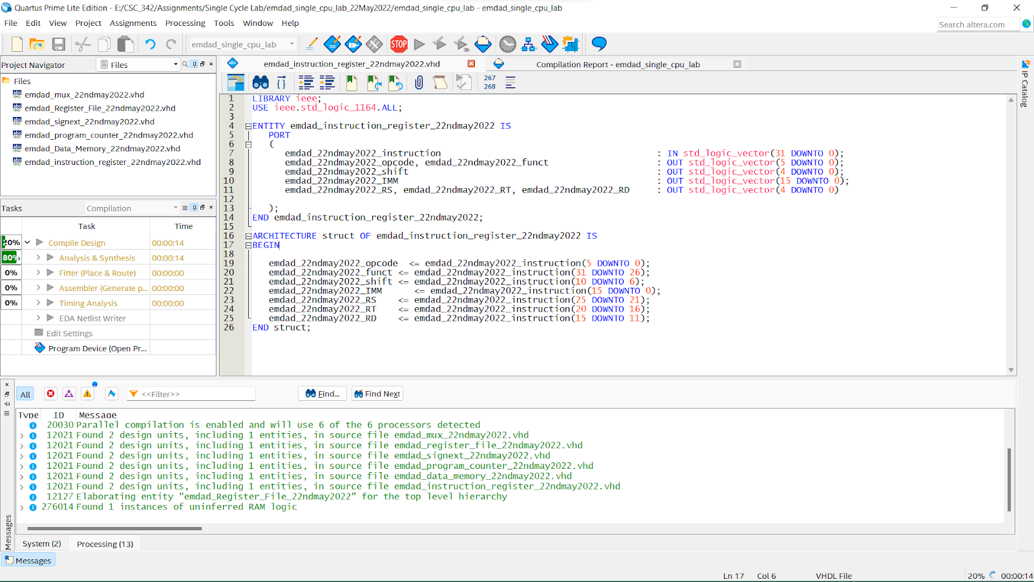

Figure 15: VHDL code the instruction Register

In figure 16,we can see that the code compiled successfully.

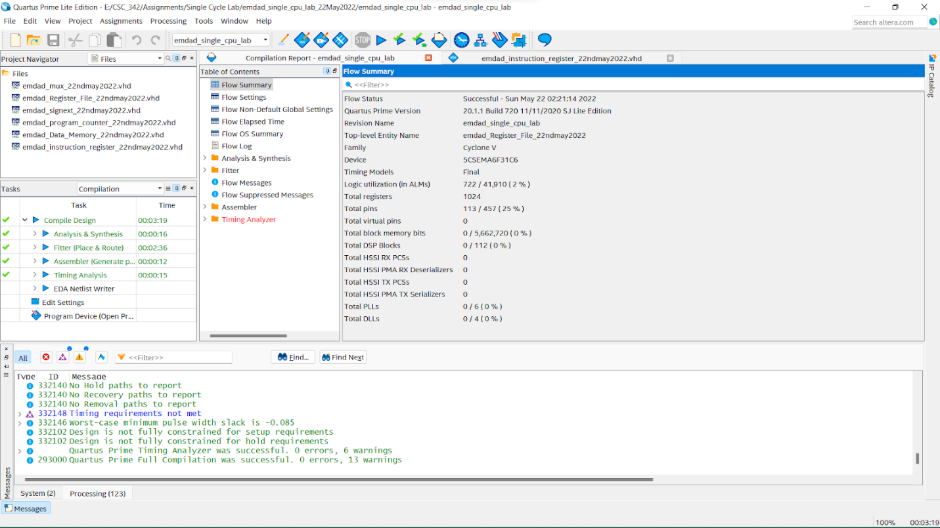

Figure 16: compiled successfully

## Instruction Memory:

In figure 17, we can see the VHDL code the instruction memory. I have 1 input and 1 output.

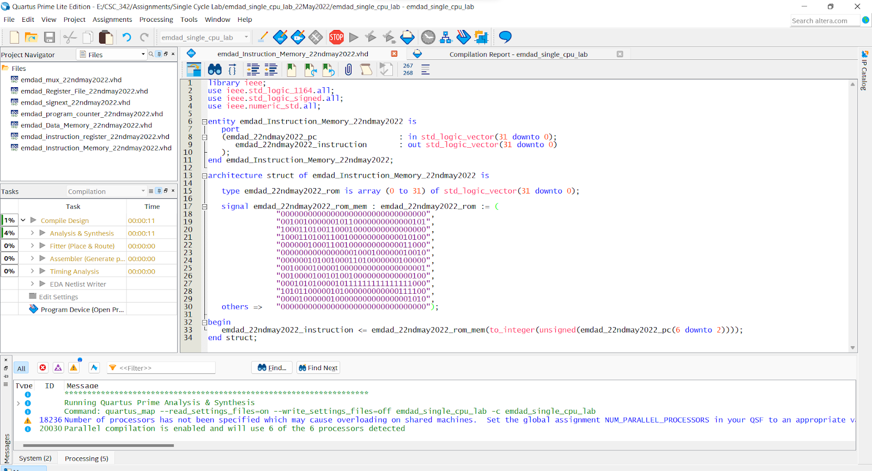

Figure 17: VHDL code the instruction memory

In figure 18,we can see that the code compiled successfully.

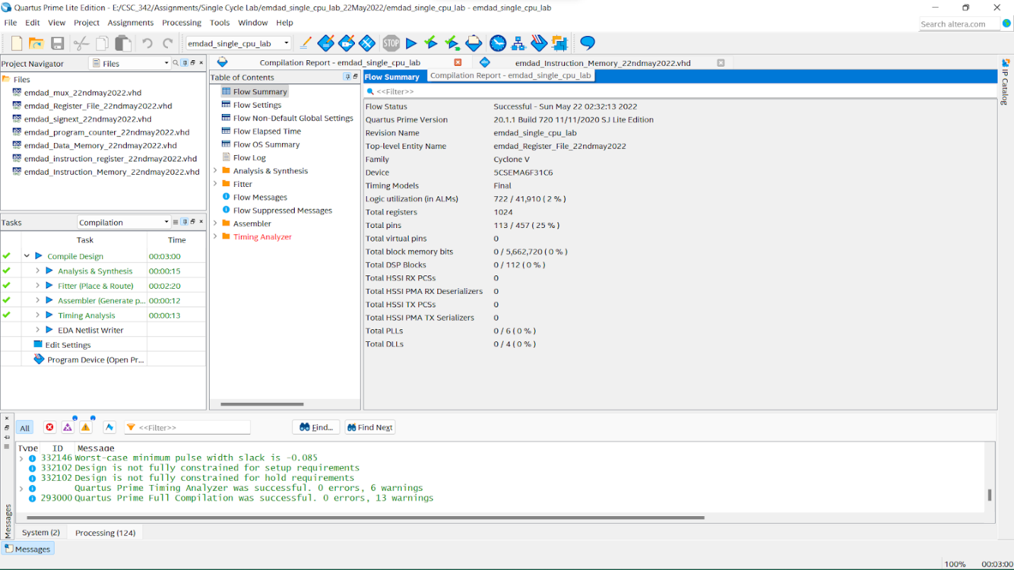

Figure 18: compiled successfully.

## Arithmetic Logic Unit (ALU):

In figure 19, we can see the VHDL code the ALU. I have 4 inputs and 3 outputs.

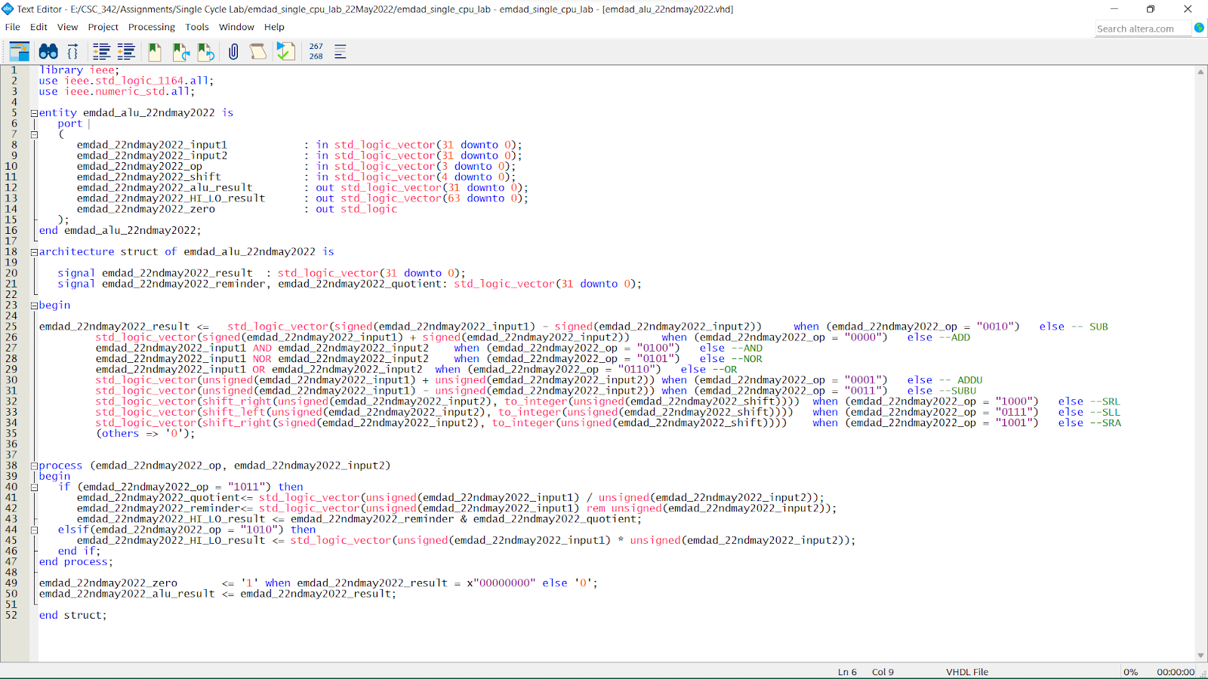

Figure 19: VHDL code the ALU

In figure 20, we can see that the code compiled successfully.

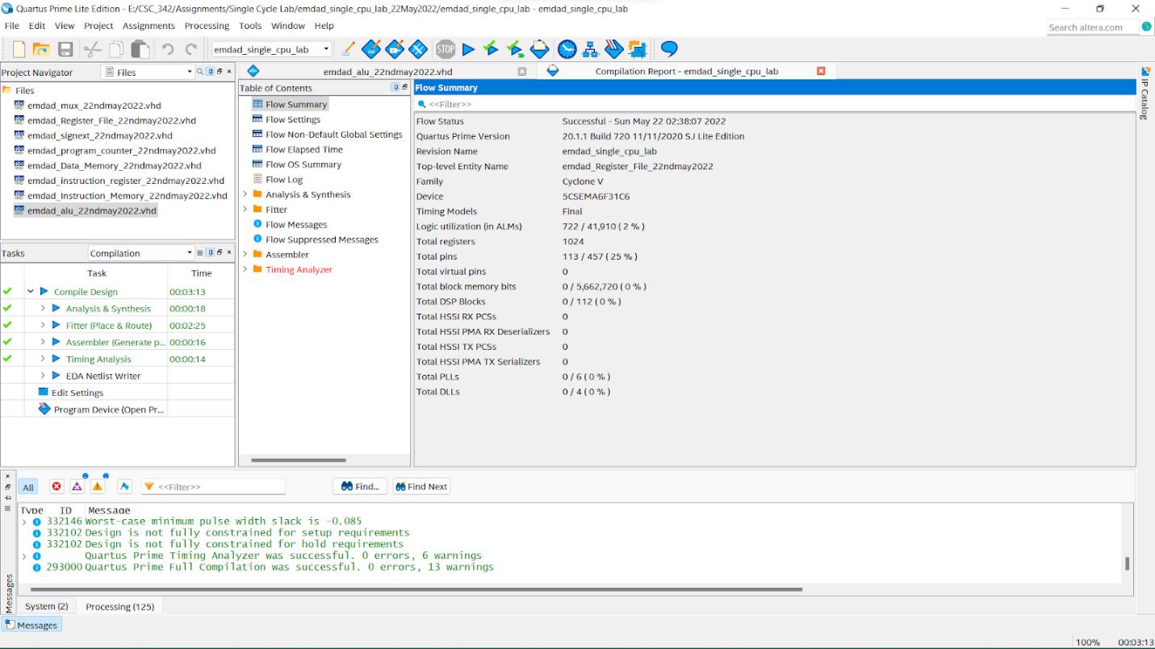

Figure 20: compiled successfully

## Control Unit:

In figure 21, we can see the VHDL code the control unit. I have 2 inputs and 11 outputs.

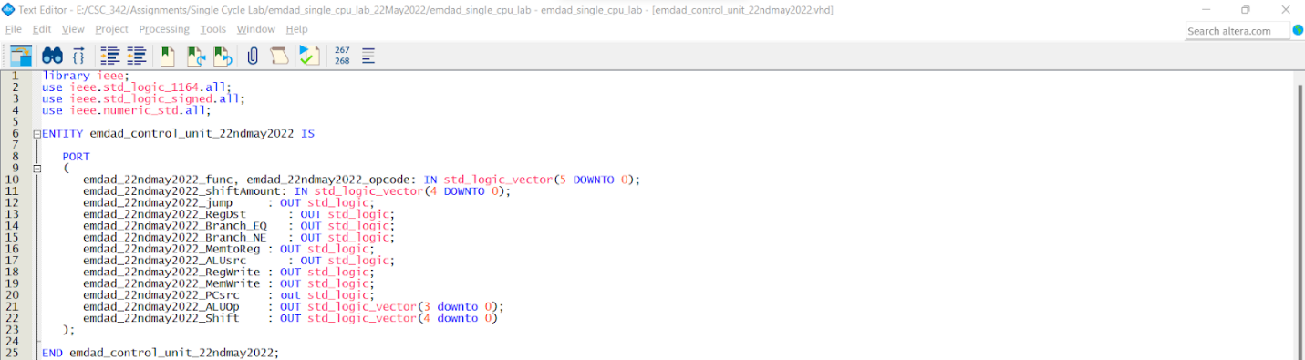

Figure 21: VHDL code the control unit (Part 1)

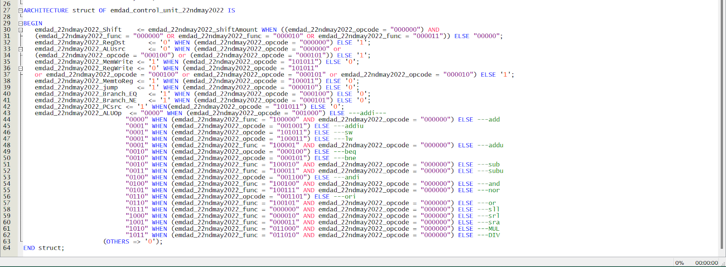

Figure 22: VHDL code the control unit (Part 2)

In figure 23, we can see that the code compiled successfully.

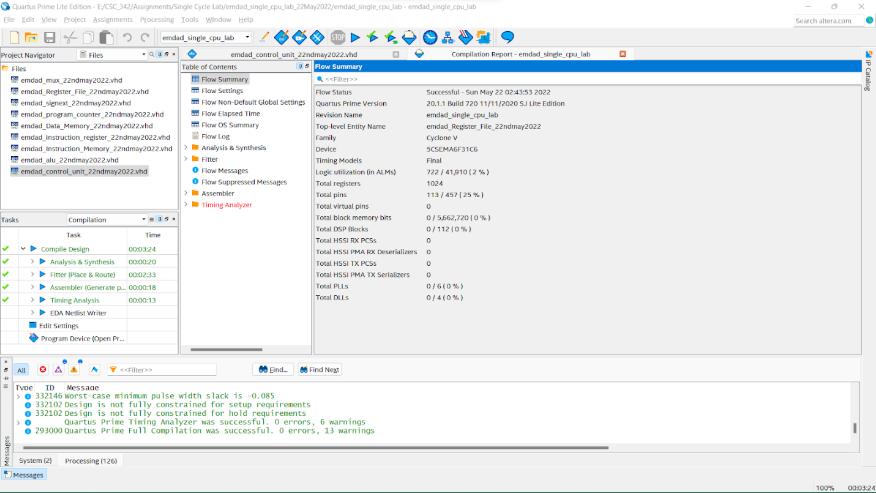

Figure 23: compiled successfully

## MIPS:

In figure 24, we can see the VHDL code the CPU datapath. I have 1 input and 1 output.

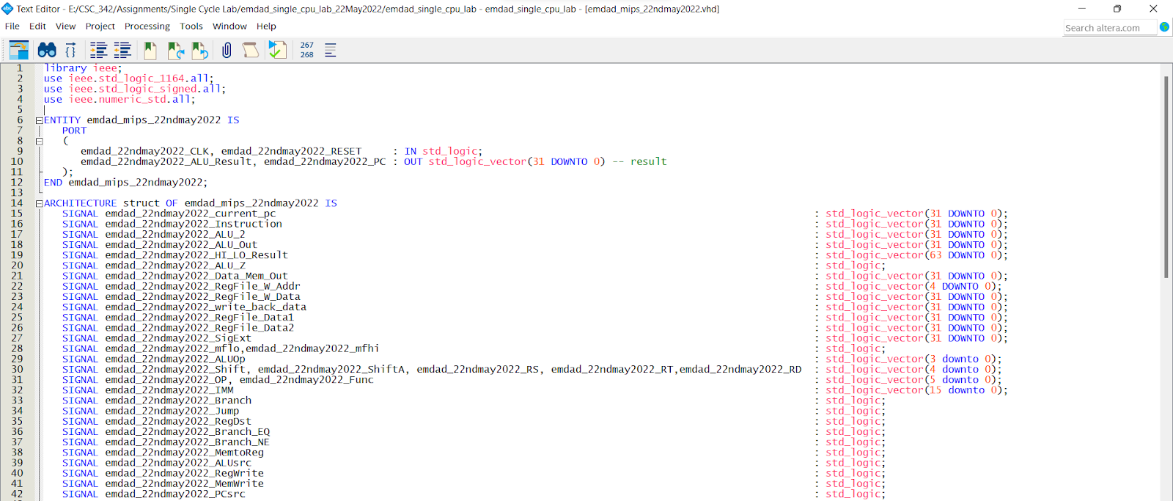

Figure 24: VHDL code the CPU Datapath (part 1)

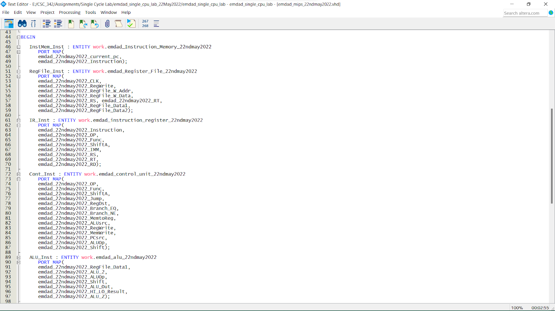

Figure 25: VHDL code the CPU Datapath (part 2)

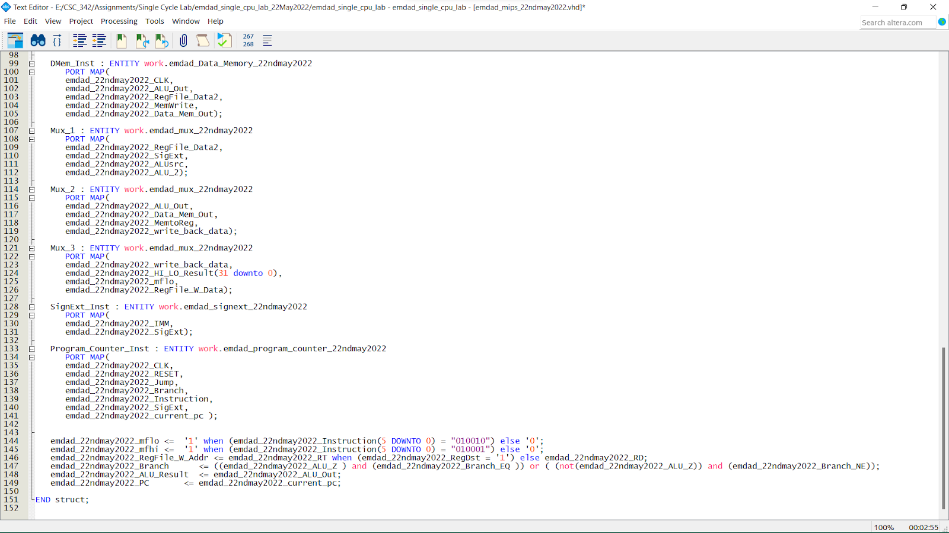

Figure 26: VHDL code the CPU Datapath (part 3)

In figure 27, we can see that the code compiled successfully.

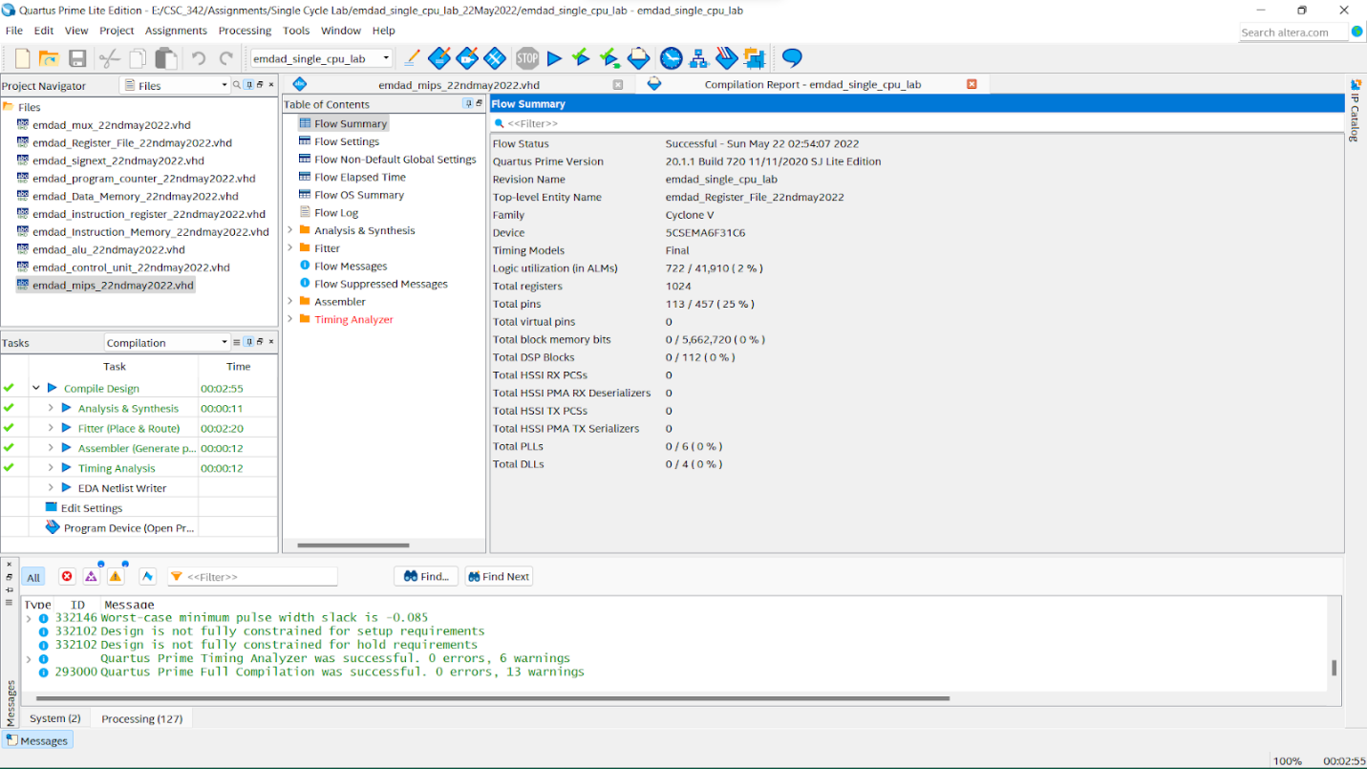

Figure 27: compiled successfully

# Block Diagrams:

In figure 28, we can see the symbol diagram generated from the VHDL code of mux file.

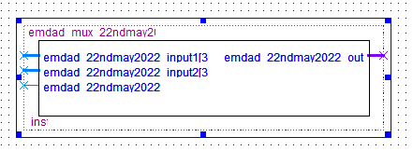

Figure 28: symbol diagram generated from the VHDL code of mux file

In figure 29, we can see the symbol diagram generated from the VHDL code of register file.

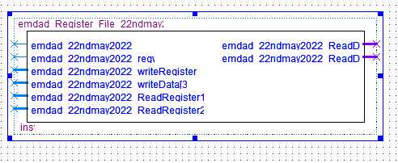

Figure 29: symbol diagram generated from the VHDL code of register file.

In figure 30, we can see the symbol diagram generated from the VHDL code of sign extender file.

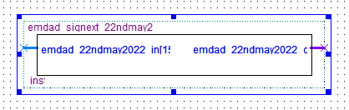

Figure 30: symbol diagram generated from VHDL code of sign extender file

In figure 31, we can see the symbol diagram generated from the VHDL code of program counter file.

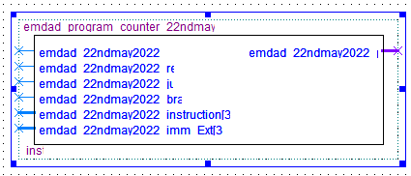

Figure 31: symbol diagram generated from VHDL code of program counter file

In figure 32, we can see the symbol diagram generated from the VHDL code of data memory file.

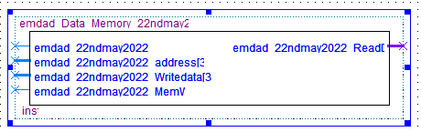

Figure 32: symbol diagram generated from VHDL code of data memory file

In figure 33, we can see the symbol diagram generated from the VHDL code of instruction register file.

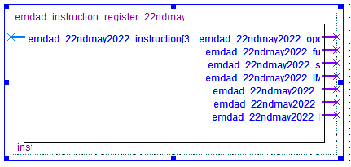

Figure 33: symbol diagram generated from VHDL code of instruction register file

In figure 34, we can see the symbol diagram generated from the VHDL code of instruction memory file.

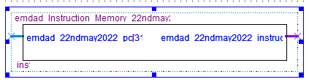

Figure 34: symbol diagram generated from VHDL code of instruction memory file

In figure 35, we can see the symbol diagram generated from the VHDL code of arithmetic logic unit (ALU) file.

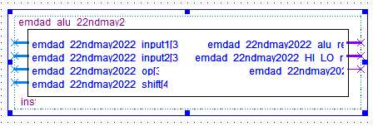

Figure 35: symbol diagram generated from VHDL code of alu file

In figure 36, we can see the symbol diagram generated from the VHDL code of control unit file.

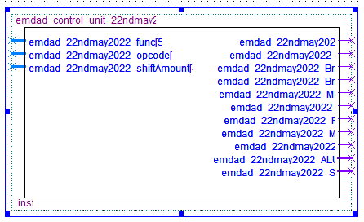

Figure 36: symbol diagram generated from VHDL code of control unit file

In figure 36, we can see the symbol diagram generated from the VHDL code of mips file.

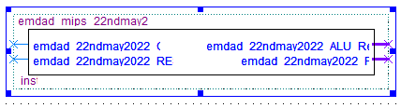

Figure 37: symbol diagram generated from VHDL code of mips file

# MIPS:

In figure 38, we can see the MIPS code which add integers and return the sum of it.

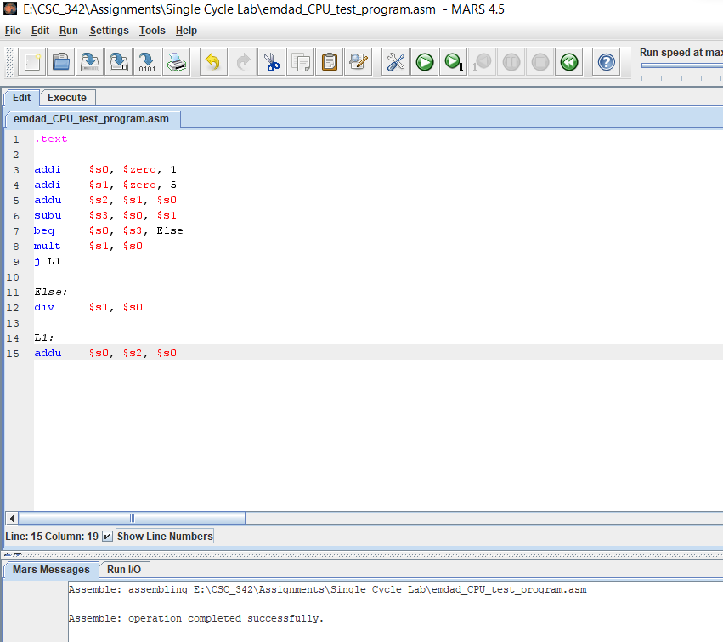

Figure 38: MIPS code

In figure 39, we can see it assembles successfully.



Figure 39: assembles successfully

# Simulation:

In figure 40, we can see MIPS code executed, text segment, data segment, registers.

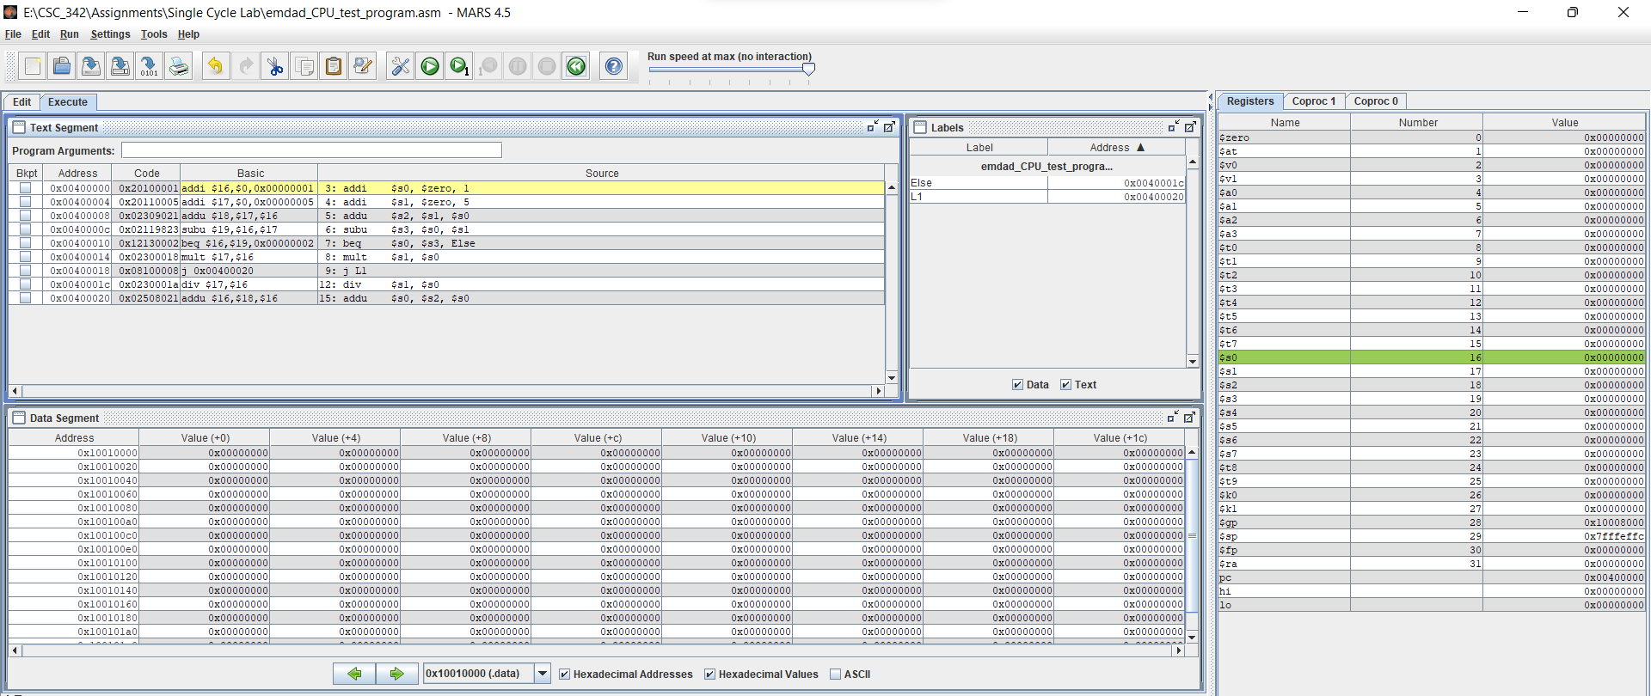

Figure 40: text segment, data segment, registers

We can see **$s0** is 1 and **$s1** is 5 and then the program does the sum. The below code did the sum



After that, we can see $s2is 6 and it jumped it to **lo**.

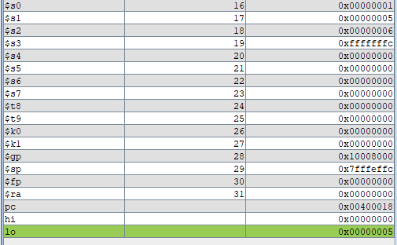

In figure 41, we can see the directory for the CPU project for ModelSim. All the files compiled without any errors.

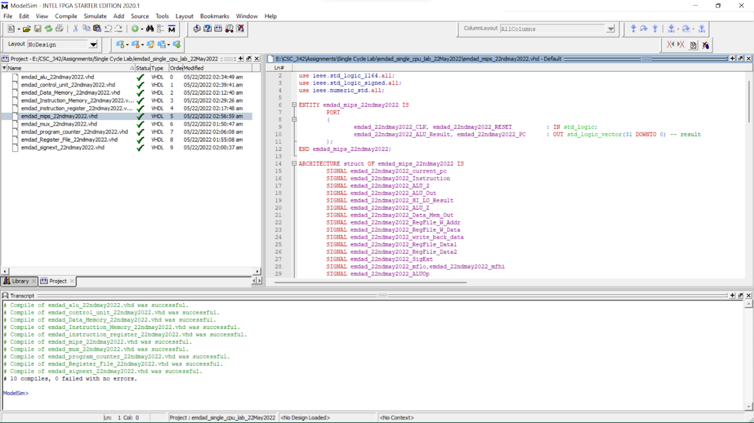

Figure 41: directory for the CPU project for ModelSim

In figure 42, we can see the simulation for the addition operation. I used the addition operation where R[rd] = R[rs] + R[rt].

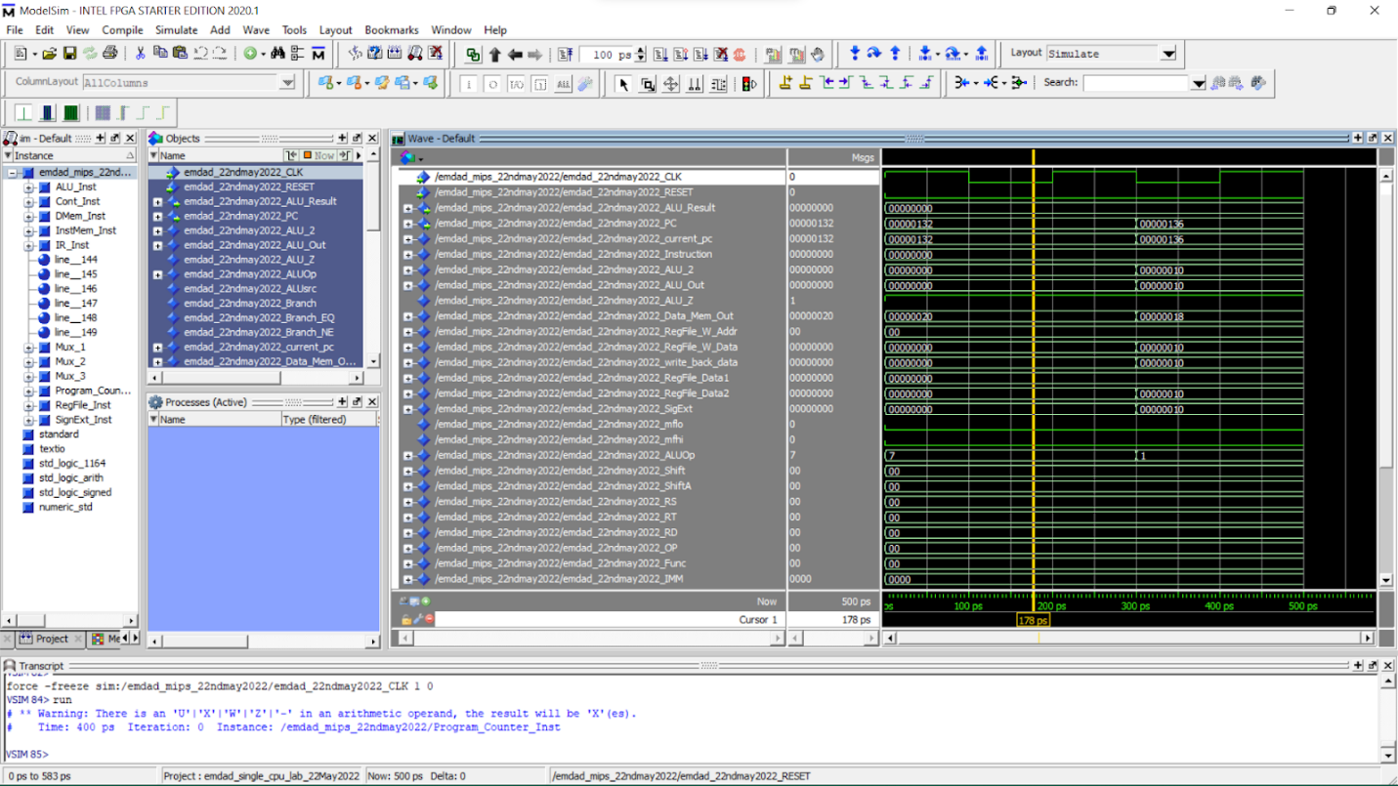

Figure 41: add operation

In figure 42, we can see the simulation for subtraction of MIPS instructions followed the equation, R[rd] = R[rs] - R[rt]. The zero flag and negative flag is 0 because the result is not 0 and positive and there is no overflow occurred as the operation was unsigned.

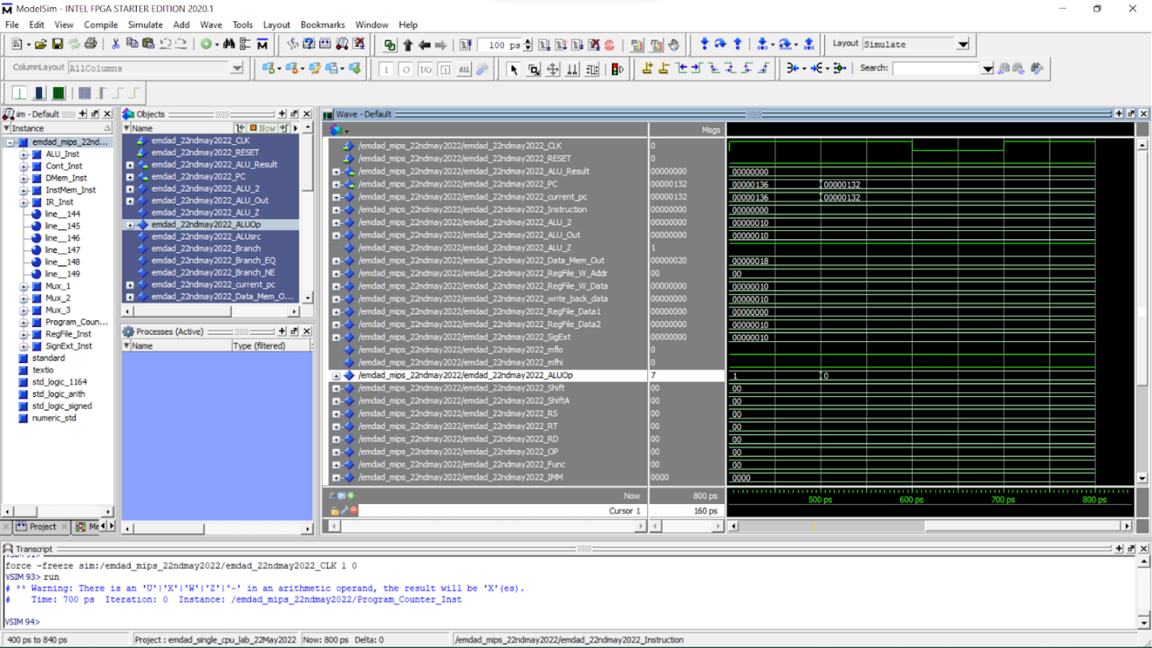

Figure 42: subtraction operation

In figure 43, we can see the simulation for multiplication of MIPS instructions.

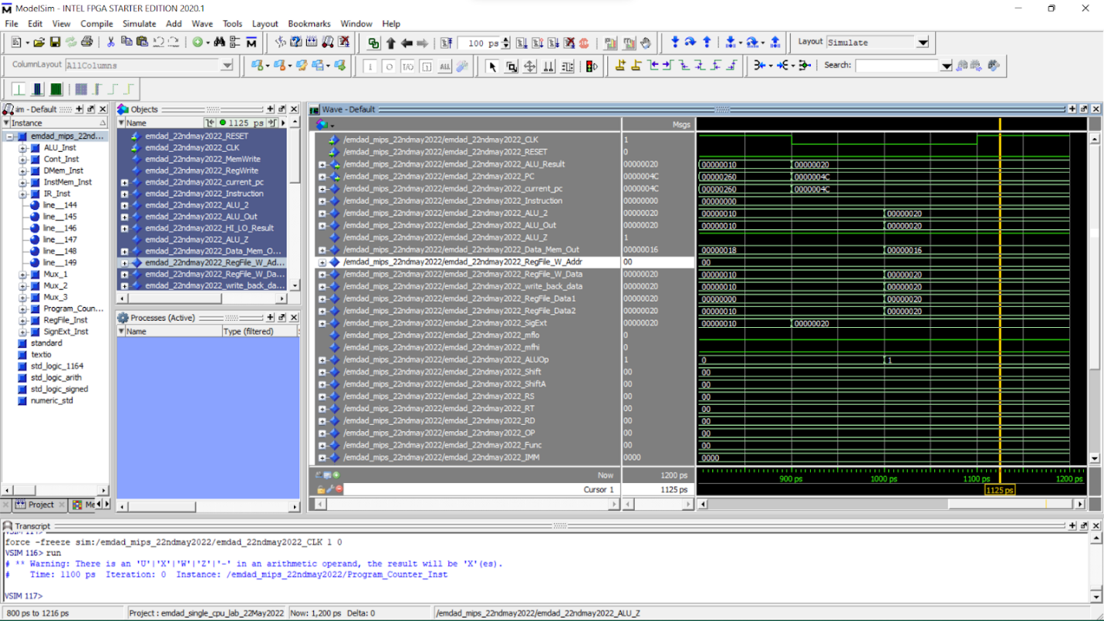

Figure 43: multiplication operation

# Conclusion:

In this assignment, I learned how to learn and develop a single cycle CPU using Quartus and Modelsim. It was a good practice on Modelsim for circuit simulation. The experiment taught me how to design and implement in VHDL CPU controller that generates control signals to determine the data path for each instruction. The operations logics were helpful to learn easily. I relearned and reviewed the concept again and which will help me in the course further.